一、创建数据库对象、用户信息及插入业务数据
1、创建数据库及用户信息
-- 创建数据库
CREATE DATABASE ZMS_BANK_DB CHARACTER SET utf8mb4 COLLATE utf8mb4_unicode_ci;

-- 创建专用用户
CREATE USER 'ZMS_ADMIN'@'%' IDENTIFIED BY 'SecurePass123#';
GRANT ALL PRIVILEGES ON ZMS_BANK_DB.* TO 'ZMS_ADMIN'@'%';
FLUSH PRIVILEGES;
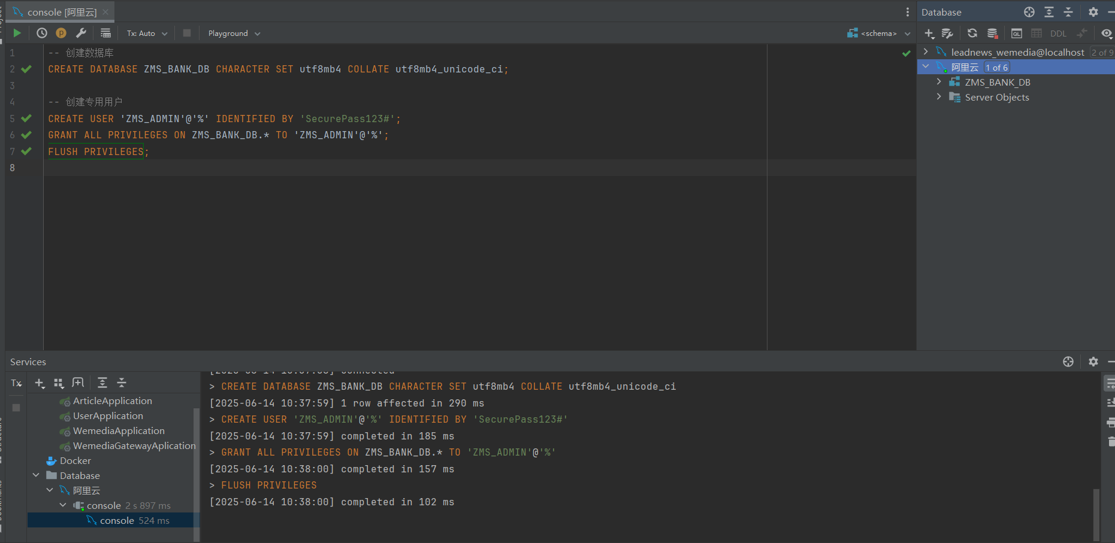
2、创建数据库表结构
- {USE ZMS_BANK_DB;

- -- 支行表
- CREATE TABLE ZMS_BRANCH (
- branch_id VARCHAR(10) PRIMARY KEY,
- branch_name VARCHAR(50) NOT NULL UNIQUE,
- city VARCHAR(50) NOT NULL,
- assets DECIMAL(15,2) DEFAULT 0.00
- ) ENGINE=InnoDB;

- -- 员工表
- CREATE TABLE ZMS_EMPLOYEE (
- employee_id VARCHAR(18) PRIMARY KEY,
- employee_name VARCHAR(50) NOT NULL,
- phone VARCHAR(20),
- address VARCHAR(100),
- start_date DATE NOT NULL,
- branch_id VARCHAR(10) NOT NULL,
- manager_id VARCHAR(18),
- employee_type ENUM('MANAGER', 'STAFF') NOT NULL,
- FOREIGN KEY (branch_id) REFERENCES ZMS_BRANCH(branch_id),
- FOREIGN KEY (manager_id) REFERENCES ZMS_EMPLOYEE(employee_id)
- ) ENGINE=InnoDB;

- -- 客户表
- CREATE TABLE ZMS_CUSTOMER (
- customer_id VARCHAR(18) PRIMARY KEY,
- customer_name VARCHAR(50) NOT NULL,
- street VARCHAR(100),
- city VARCHAR(50),
- loan_manager_id VARCHAR(18),
- account_manager_id VARCHAR(18),
- FOREIGN KEY (loan_manager_id) REFERENCES ZMS_EMPLOYEE(employee_id),
- FOREIGN KEY (account_manager_id) REFERENCES ZMS_EMPLOYEE(employee_id)
- ) ENGINE=InnoDB;

- -- 账户总表（多态设计）
- CREATE TABLE ZMS_ACCOUNT (
- account_no VARCHAR(20) PRIMARY KEY,
- branch_id VARCHAR(10) NOT NULL,
- balance DECIMAL(15,2) DEFAULT 0.00,
- last_access DATE,
- account_type ENUM('SAVING', 'LOAN') NOT NULL,
- FOREIGN KEY (branch_id) REFERENCES ZMS_BRANCH(branch_id)
- ) ENGINE=InnoDB;

- -- 储蓄账户扩展
- CREATE TABLE ZMS_SAVING_ACCOUNT (
- account_no VARCHAR(20) PRIMARY KEY,
- interest_rate DECIMAL(5,4) NOT NULL,
- FOREIGN KEY (account_no) REFERENCES ZMS_ACCOUNT(account_no)
- ) ENGINE=InnoDB;

- -- 贷款账户扩展
- CREATE TABLE ZMS_LOAN_ACCOUNT (
- account_no VARCHAR(20) PRIMARY KEY,
- overdraft_limit DECIMAL(15,2) NOT NULL,
- FOREIGN KEY (account_no) REFERENCES ZMS_ACCOUNT(account_no)
- ) ENGINE=InnoDB;

- -- 客户-账户关系
- CREATE TABLE ZMS_CUSTOMER_ACCOUNT (
- customer_id VARCHAR(18) NOT NULL,
- account_no VARCHAR(20) NOT NULL,
- PRIMARY KEY (customer_id, account_no),
- FOREIGN KEY (customer_id) REFERENCES ZMS_CUSTOMER(customer_id),
- FOREIGN KEY (account_no) REFERENCES ZMS_ACCOUNT(account_no)
- ) ENGINE=InnoDB;

- -- 贷款主表
- CREATE TABLE ZMS_LOAN (
- loan_id VARCHAR(20) PRIMARY KEY,
- customer_id VARCHAR(18) NOT NULL,
- branch_id VARCHAR(10) NOT NULL,
- loan_amount DECIMAL(15,2) NOT NULL,
- account_no VARCHAR(20),
- FOREIGN KEY (customer_id) REFERENCES ZMS_CUSTOMER(customer_id),
- FOREIGN KEY (branch_id) REFERENCES ZMS_BRANCH(branch_id),
- FOREIGN KEY (account_no) REFERENCES ZMS_LOAN_ACCOUNT(account_no)
- ) ENGINE=InnoDB;

- -- 还款记录表
- CREATE TABLE ZMS_LOAN_PAYMENT (
- payment_id INT AUTO_INCREMENT PRIMARY KEY,
- loan_id VARCHAR(20) NOT NULL,
- payment_date DATE NOT NULL,
- amount DECIMAL(15,2) NOT NULL,
- FOREIGN KEY (loan_id) REFERENCES ZMS_LOAN(loan_id)
- ) ENGINE=InnoDB;

- -- 索引优化
- CREATE INDEX idx_branch_city ON ZMS_BRANCH(city);
- CREATE INDEX idx_emp_branch ON ZMS_EMPLOYEE(branch_id);
- CREATE INDEX idx_acc_access ON ZMS_ACCOUNT(last_access);
- CREATE INDEX idx_loan_customer ON ZMS_LOAN(customer_id);
- CREATE INDEX idx_payment_loan ON ZMS_LOAN_PAYMENT(loan_id);

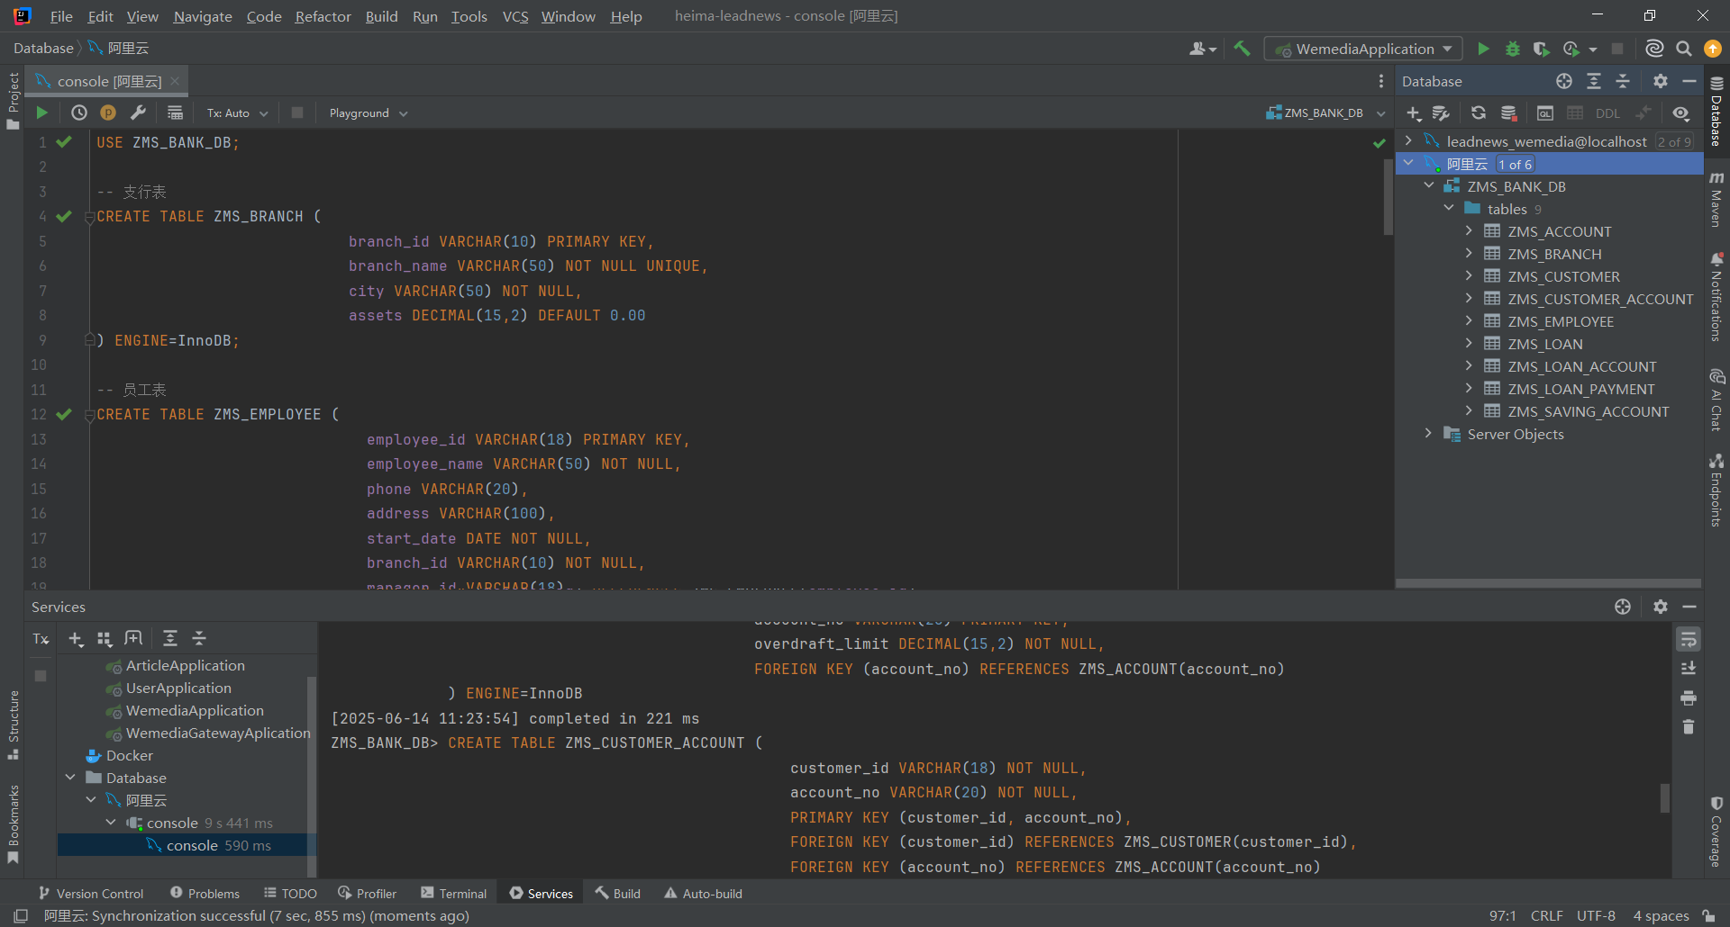
3、插入模拟业务数据
- -- 1. 创建存储过程生成测试数据
- DELIMITER $$

- CREATE PROCEDURE ZMS_GenerateTestData()
- BEGIN
- DECLARE i INT DEFAULT 1;

- -- 支行数据 (5家支行)
- INSERT INTO ZMS_BRANCH VALUES
- ('B001', '上海陆家嘴支行', '上海', 100000000.00),
- ('B002', '北京金融街支行', '北京', 85000000.00),
- ('B003', '广州天河支行', '广州', 75000000.00),
- ('B004', '深圳南山支行', '深圳', 92000000.00),
- ('B005', '杭州西湖支行', '杭州', 68000000.00);

- -- 员工数据 (50人)
- INSERT INTO ZMS_EMPLOYEE (employee_id, employee_name, phone, address, start_date, branch_id, manager_id, employee_type)
- VALUES
- ('110101199001011234', '张美苏', '13800138000', '北京市海淀区中关村大街1号', '2015-06-01', 'B001', NULL, 'MANAGER');

- SET i = 2;
- WHILE i <= 50 DO
- INSERT INTO ZMS_EMPLOYEE (employee_id, employee_name, phone, address, start_date, branch_id, manager_id, employee_type)
- VALUES (
- CONCAT('ID', LPAD(i, 16, '0')),
- CONCAT('员工', i),
- CONCAT('138', LPAD(FLOOR(RAND()*100000000), 8, '0')),
- CONCAT('城市', FLOOR(RAND()*5)+1, '街道', FLOOR(RAND()*100)+1),
- DATE_SUB(CURDATE(), INTERVAL FLOOR(RAND()*3650) DAY),
- CONCAT('B00', FLOOR(RAND()*5)+1),
- CASE WHEN i%5=0 THEN '110101199001011234' ELSE NULL END,
- CASE WHEN i%10=0 THEN 'MANAGER' ELSE 'STAFF' END
- );
- SET i = i + 1;
- END WHILE;

- -- 客户数据 (120人)
- SET i = 1;
- WHILE i <= 120 DO
- INSERT INTO ZMS_CUSTOMER (customer_id, customer_name, street, city, loan_manager_id, account_manager_id)
- VALUES (
- CONCAT('CUST', LPAD(i, 14, '0')),
- CONCAT('客户', i),
- CONCAT('街道', FLOOR(RAND()*50)+1),
- ELT(FLOOR(RAND()*5)+1, '北京', '上海', '广州', '深圳', '杭州'),
- CASE WHEN i%3=0 THEN (SELECT employee_id FROM ZMS_EMPLOYEE ORDER BY RAND() LIMIT 1) ELSE NULL END,
- CASE WHEN i%4=0 THEN (SELECT employee_id FROM ZMS_EMPLOYEE ORDER BY RAND() LIMIT 1) ELSE NULL END
- );
- SET i = i + 1;
- END WHILE;

- -- 账户数据 (300个)
- SET i = 1;
- WHILE i <= 300 DO
- INSERT INTO ZMS_ACCOUNT (account_no, branch_id, balance, last_access, account_type)
- VALUES (
- CONCAT('AC', LPAD(i, 18, '0')),
- CONCAT('B00', FLOOR(RAND()*5)+1),
- ROUND(RAND()*1000000, 2),
- DATE_SUB(CURDATE(), INTERVAL FLOOR(RAND()*365) DAY),
- ELT(FLOOR(RAND()*2)+1, 'SAVING', 'LOAN')
- );

- IF (SELECT account_type FROM ZMS_ACCOUNT WHERE account_no = CONCAT('AC', LPAD(i, 18, '0'))) = 'SAVING' THEN
- INSERT INTO ZMS_SAVING_ACCOUNT VALUES (
- CONCAT('AC', LPAD(i, 18, '0')),
- ROUND(RAND()*0.04 + 0.01, 4)
- );
- ELSE
- INSERT INTO ZMS_LOAN_ACCOUNT VALUES (
- CONCAT('AC', LPAD(i, 18, '0')),
- ROUND(RAND()*45000 + 5000, 2)
- );
- END IF;

- SET i = i + 1;
- END WHILE;

- -- 客户-账户关系 (500个)
- SET i = 1;
- WHILE i <= 500 DO
- INSERT IGNORE INTO ZMS_CUSTOMER_ACCOUNT (customer_id, account_no)
- SELECT
- (SELECT customer_id FROM ZMS_CUSTOMER ORDER BY RAND() LIMIT 1),
- (SELECT account_no FROM ZMS_ACCOUNT ORDER BY RAND() LIMIT 1);
- SET i = i + 1;
- END WHILE;

- -- 贷款数据 (100笔)
- SET i = 1;
- WHILE i <= 100 DO
- INSERT INTO ZMS_LOAN (loan_id, customer_id, branch_id, loan_amount, account_no)
- VALUES (
- CONCAT('LN', LPAD(i, 18, '0')),
- (SELECT customer_id FROM ZMS_CUSTOMER ORDER BY RAND() LIMIT 1),
- CONCAT('B00', FLOOR(RAND()*5)+1),
- ROUND(RAND()*490000 + 10000, 2),
- (SELECT account_no FROM ZMS_LOAN_ACCOUNT ORDER BY RAND() LIMIT 1)
- );

- -- 每笔贷款生成5-10次还款
- SET @payments = FLOOR(RAND()*6) + 5;
- SET @j = 1;
- WHILE @j <= @payments DO
- INSERT INTO ZMS_LOAN_PAYMENT (loan_id, payment_date, amount)
- VALUES (
- CONCAT('LN', LPAD(i, 18, '0')),
- DATE_SUB(CURDATE(), INTERVAL FLOOR(RAND()*330) DAY),
- ROUND(RAND()*19000 + 1000, 2)
- );
- SET @j = @j + 1;
- END WHILE;

- SET i = i + 1;
- END WHILE;
- END$$

- DELIMITER ;

- -- 2. 执行数据生成
- CALL ZMS_GenerateTestData();

- -- 3. 验证数据量
- SELECT
- (SELECT COUNT(*) FROM ZMS_CUSTOMER) AS customers,
- (SELECT COUNT(*) FROM ZMS_ACCOUNT) AS accounts,
- (SELECT COUNT(*) FROM ZMS_LOAN_PAYMENT) AS transactions;
员工表数据展示图
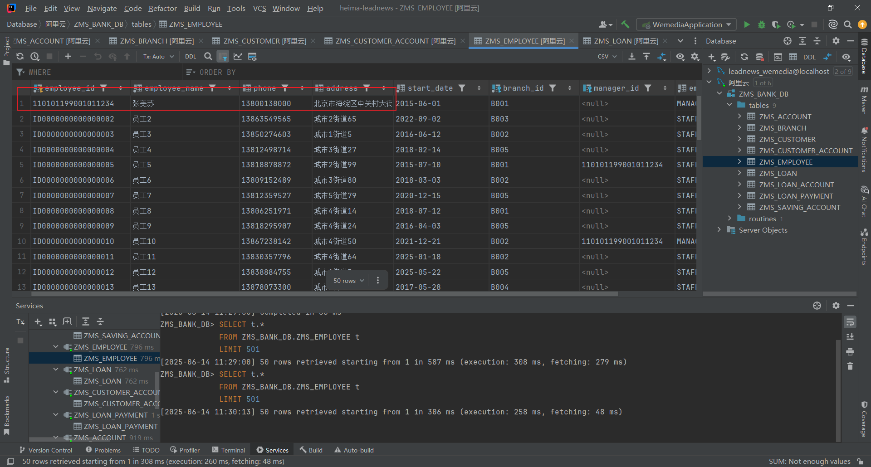
二、数据库E-R图
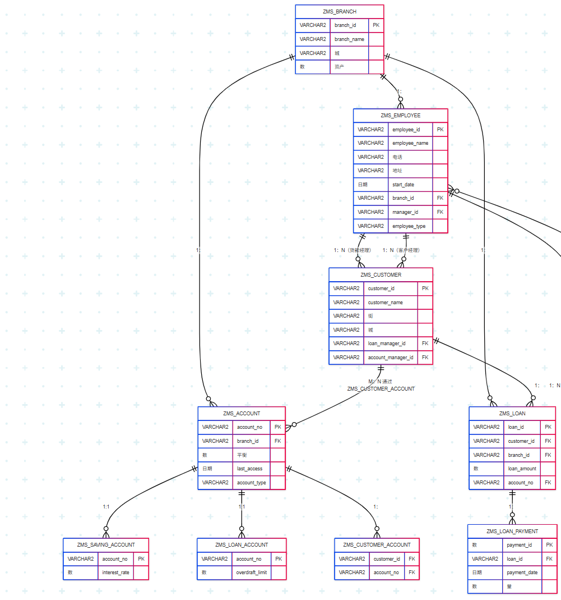
三、使用SQL脚本分析出优质客户并对客户标星
根据银行业务特点，制定以下5星级客户评判标准：
星级 | 评判标准
★★★★★ | 总资产 ≥ 100万，账户数 ≥ 3，无逾期记录，近半年有交易
★★★★ | 总资产 ≥ 50万，账户数 ≥ 2，无逾期记录，近1年有交易
★★★ | 总资产 ≥ 20万，账户数 ≥ 1，无严重逾期
★★ | 总资产 ≥ 5万，有活跃账户
★ | 总资产 < 5万 或 无活跃账户
SQL脚本如下：
1. 客户评级表
- CREATE TABLE ZMS_CUSTOMER_RATING (
- customer_id VARCHAR(18) PRIMARY KEY,
- total_assets DECIMAL(15,2) NOT NULL,
- account_count INT NOT NULL,
- has_overdue BOOLEAN NOT NULL,
- last_transaction_date DATE,
- rating TINYINT NOT NULL CHECK (rating BETWEEN 1 AND 5),
- rating_date DATE NOT NULL,
- FOREIGN KEY (customer_id) REFERENCES ZMS_CUSTOMER(customer_id)
- ) ENGINE=InnoDB;

- CREATE INDEX idx_rating ON ZMS_CUSTOMER_RATING(rating);
2. 评级计算存储过程

CREATE PROCEDURE ZMS_CalculateCustomerRating()
- BEGIN
- -- 清空旧评级数据
- TRUNCATE TABLE ZMS_CUSTOMER_RATING;

- -- 计算客户资产和账户信息
- INSERT INTO ZMS_CUSTOMER_RATING (
- customer_id,
- total_assets,
- account_count,
- has_overdue,
- last_transaction_date,
- rating_date
- )
- SELECT
- c.customer_id,
- COALESCE(SUM(a.balance), 0) AS total_assets,
- COUNT(DISTINCT ca.account_no) AS account_count,
- MAX(CASE WHEN lp.payment_date > DATE_ADD(l.issue_date, INTERVAL 30 DAY) THEN 1 ELSE 0 END) AS has_overdue,
- MAX(a.last_access) AS last_transaction_date,
- CURDATE()
- FROM ZMS_CUSTOMER c
- LEFT JOIN ZMS_CUSTOMER_ACCOUNT ca ON c.customer_id = ca.customer_id
- LEFT JOIN ZMS_ACCOUNT a ON ca.account_no = a.account_no
- LEFT JOIN ZMS_LOAN l ON c.customer_id = l.customer_id
- LEFT JOIN ZMS_LOAN_PAYMENT lp ON l.loan_id = lp.loan_id
- GROUP BY c.customer_id;

- -- 更新星级评级
- UPDATE ZMS_CUSTOMER_RATING
- SET rating =
- CASE
- WHEN total_assets >= 1000000 AND account_count >= 3 AND has_overdue = 0
- AND last_transaction_date >= DATE_SUB(CURDATE(), INTERVAL 6 MONTH)
- THEN 5
- WHEN total_assets >= 500000 AND account_count >= 2 AND has_overdue = 0
- AND last_transaction_date >= DATE_SUB(CURDATE(), INTERVAL 12 MONTH)
- THEN 4
- WHEN total_assets >= 200000 AND account_count >= 1
- AND (has_overdue = 0 OR total_assets >= 500000)
- THEN 3
- WHEN total_assets >= 50000 THEN 2
- ELSE 1
- END;

- -- 添加VIP客户标识
- ALTER TABLE ZMS_CUSTOMER
- ADD COLUMN is_vip BOOLEAN DEFAULT FALSE,
- ADD COLUMN vip_level TINYINT DEFAULT 0;

- UPDATE ZMS_CUSTOMER c
- JOIN ZMS_CUSTOMER_RATING r ON c.customer_id = r.customer_id
- SET
- c.is_vip = (r.rating >= 4),
- c.vip_level = r.rating;
- END$$

- DELIMITER ;
3. 执行评级计算
- -- 执行评级计算
- CALL ZMS_CalculateCustomerRating();

- -- 查看评级结果
- SELECT
- c.customer_id,
- c.customer_name,
- r.total_assets,
- r.account_count,
- r.rating,
- CASE r.rating
- WHEN 5 THEN '★★★★★'
- WHEN 4 THEN '★★★★'
- WHEN 3 THEN '★★★'
- WHEN 2 THEN '★★'
- ELSE '★'
- END AS rating_stars,
- r.rating_date
- FROM ZMS_CUSTOMER c
- JOIN ZMS_CUSTOMER_RATING r ON c.customer_id = r.customer_id
- ORDER BY r.rating DESC, r.total_assets DESC;
4. 客户分布分析
- -- 各星级客户分布
- SELECT
- rating,
- CASE rating
- WHEN 5 THEN '★★★★★'
- WHEN 4 THEN '★★★★'
- WHEN 3 THEN '★★★'
- WHEN 2 THEN '★★'
- ELSE '★'
- END AS rating_stars,
- COUNT(*) AS customer_count,
- ROUND(COUNT(*) * 100 / (SELECT COUNT(*) FROM ZMS_CUSTOMER_RATING), 2) AS percentage,
- CONCAT('■', REPEAT('■', FLOOR(COUNT(*) * 10 / (SELECT MAX(customer_count) FROM
- (SELECT rating, COUNT(*) AS customer_count FROM ZMS_CUSTOMER_RATING GROUP BY rating) t)))) AS distribution_chart
- FROM ZMS_CUSTOMER_RATING
- GROUP BY rating
- ORDER BY rating DESC;
5. 高价值客户识别
- -- 五星级客户详情
- SELECT
- c.customer_id,
- c.customer_name,
- c.city,
- r.total_assets,
- a.account_no,
- a.balance,
- a.last_access
- FROM ZMS_CUSTOMER c
- JOIN ZMS_CUSTOMER_RATING r ON c.customer_id = r.customer_id
- JOIN ZMS_CUSTOMER_ACCOUNT ca ON c.customer_id = ca.customer_id
- JOIN ZMS_ACCOUNT a ON ca.account_no = a.account_no
- WHERE r.rating = 5
- ORDER BY r.total_assets DESC;
6. 潜在价值客户分析
- -- 三星级但有高增长潜力客户
- SELECT
- c.customer_id,
- c.customer_name,
- r.total_assets,
- r.account_count,
- r.rating,
- DATEDIFF(CURDATE(), r.last_transaction_date) AS days_since_last_transaction,
- (SELECT COUNT(*) FROM ZMS_LOAN l WHERE l.customer_id = c.customer_id) AS loan_count
- FROM ZMS_CUSTOMER c
- JOIN ZMS_CUSTOMER_RATING r ON c.customer_id = r.customer_id
- WHERE r.rating = 3
- AND r.total_assets >= 500000
- AND DATEDIFF(CURDATE(), r.last_transaction_date) <= 30;

